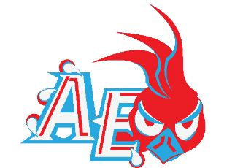
Austin East Magnet High School
Red & Blue Roadrunner Football Booster Club
Scoreboard Advertising Contract
We write to you asking you to support the Red and Blue Roadrunner Football Booster Club. The Austin-East Football team can only achieve its goals with the assistance of generous donations from members of our community.
Since our organization relies on the generosity of individuals like you, we write to ask you to consider a donation to our cause. We are a non-profit organization; therefore, your donation would be tax deductible.
We are getting a new turf field this year and we would like to raise money to have a new scoreboard to go along with the new field. The Austin-East Roadrunners scoreboard has seen better days, it has served the school for the past 25 years and sadly the manufacturer no longer makes part for the scoreboard to make any repairs.
This year we are offering 2 scoreboard advertising options, Diamond Runner and Platinum Runner. The prices are good for 3 years and include advertisement in 1middle panel or along the bottom panel in 1 of 6 available panels. Towards the end of your 3-year contract, you can renew for another 3 years at a lower price, however if there is a lapse the price returns to the initial investment.
Ad space is available on a First Come, First Serve Basis. Please see below for details.

Below are the details concerning this year’s advertising options:
Advertisement LEVELS (see attached sheet for details)
Level: Initial Investment (3years) Renewal
Diamond Runner $5,000 $3,000
Platinum Runner $3,000 $2,000

2018-2019 Board of Directors
Quineesha Phillips, President

Travonda Blair, Treasurer

Austin East Magnet High School
Red & Blue Roadrunner Football Booster Club
Scoreboard Sponsorship Form
The expectation for Austin-East Magnet High School football remains high! The Roadrunners will open the season with several talented young and veteran players. The sky is the limit for this year’s edition of Roadrunner Football!
For AEMHS to have successful football program, it will take effort and commitment from the East Knoxville Community and our loyal supporters. Below you will find advertising opportunities for the coming year:
Please complete this information and return the form with your payment.
Name: _____________________________________________________________
Address: ___________________________________________________________
City: _______________________________________________________________
Telephone: __________________________________________________________ Email________________________________________________________________
Membership level:
Diamond Runner ___ Platinum Runner _____
Donations to the Red and Blue Roadrunner Football Booster Club are tax deductible. Red and Blue Roadrunner Football Booster Club is an approved 501(c)(3) organization. Tax receipts will be provided.
Please make your check payable to: Red and Blue Roadrunner Football Booster Club
2018-2019 Board of Directors
Quineesha Phillips, President

Travonda Blair, Treasurer

Please return form to:
Red & Blue Roadrunner Football
P.O. Box 14503
Knoxville, TN 37914
423-994-1769 (c)

*******Deadline: July 15

Thank you for supporting Roadrunner FOOTBALL!!

Austin East Magnet High School
Red & Blue Roadrunner Football Booster Club
Scoreboard Advertisement Levels
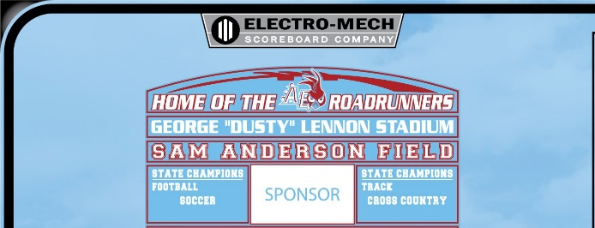
Diamond Runner ($5,000/ 3 years)
- Advertisement in middle panel (1 available)
- Panel size 8’x8’
- 2 free tickets to all home games
- Priority visibility on the AEMHS football website
- Public address announcement at all home games
- Company name on the AEMHS Football Season Poster

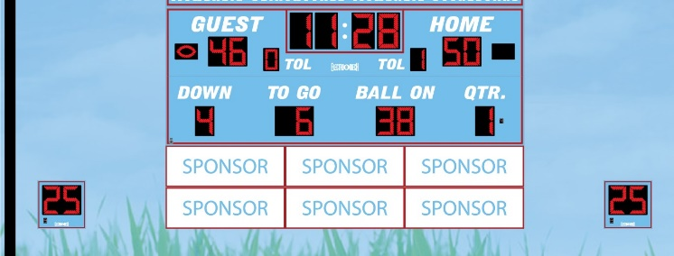
Platinum Runner ($3,000/ 3 years)
- Advertisement on bottom panel (6 available)
- Panel size 3’x3’
- 1 free ticket to all home games
- Prominent visibility on the AEMHS football website
- Company name on the AEMHS Football Season Poster

