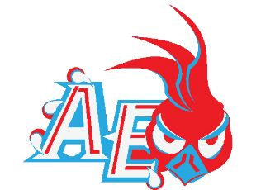
Austin East Magnet High School
Red & Blue Roadrunner Football Booster Club
Corporate Sponsorship Renewal Form
The expectation for Austin-East Magnet High School football remains high! The Roadrunners will open the season with a number of talented young and veteran players. The sky is the limit for this year’s edition of Roadrunner Football!
In order for AEMHS to have successful football program, it will take effort and commitment from the East Knoxville Community and our loyal supporters. Below you will find advertising opportunities for the coming year:

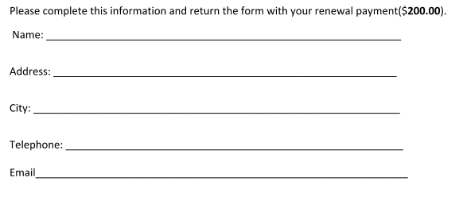
2018-2019 Board of Directors
Quineesha Phillips President

Travonda Blair, Treasurer

Quineesha Phillips, Fundraising

*****Please complete and return by August 1st to ensure continued banner placement
***********Deadline: July 1st**********

Please return form to:
Red & Blue Roadrunner Football
P. O. Box 14503
Knoxville, TN 37914
Quineesha Phillips
423-994-1769 (c )
Thank you for supporting Roadrunner FOOTBALL!!

